**Task 1: Pattern Recognition using Artificial Neural Network (ANN)**

Result for **Task 1.1** Part 2 after testing.

The Accuracy score and confusion matrix is shown below. The accuracy for the code is found to be 68%.

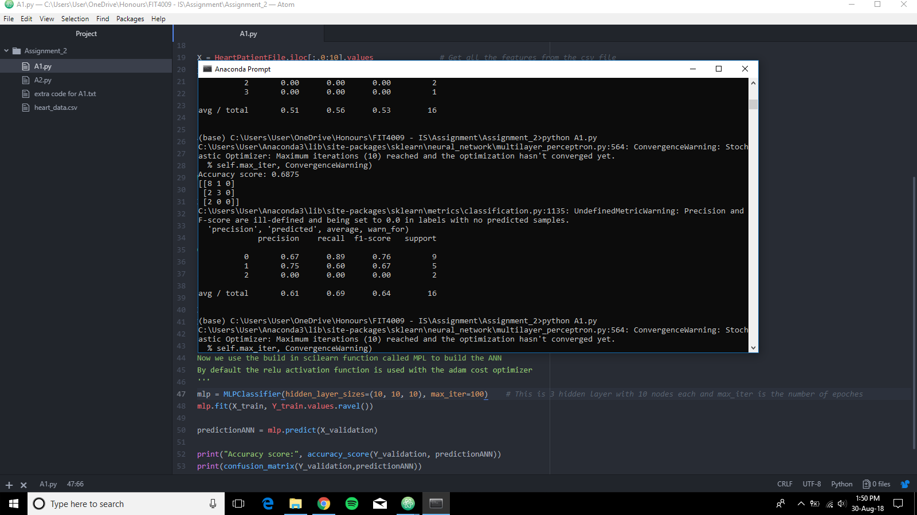

**Task 2: Image Classification using deep learning**

**Task 2.1 result**

The image blow the sucessful instillation of keras and tensorflow.

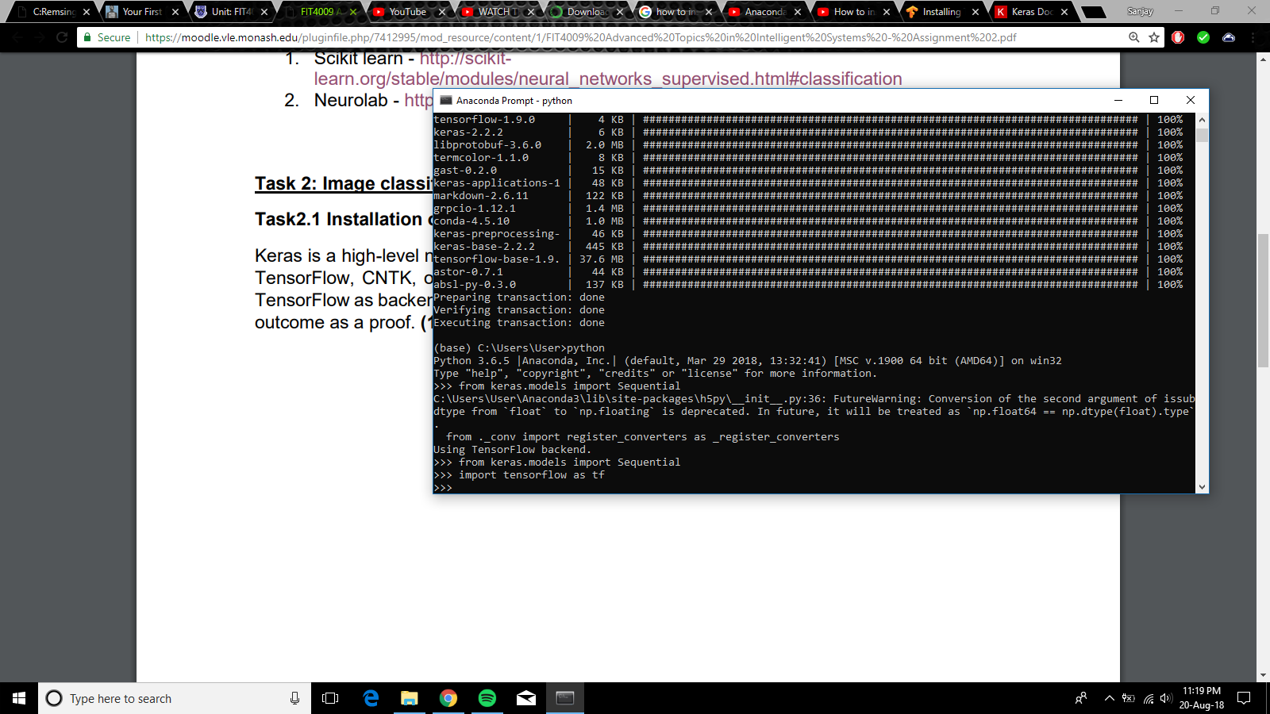

**Task 2.2 CNN model implementation**

This image classification is done on cars and planes. An image set of 40 cars and 40 planes have been used for training and 6 of each for testing. As observed from the image below the code is designed to print loss and accuracy in every epoch. The epoch is set to run for 10 times and as seen from the command prompt screenshot, the deep learning code has achieved 100% accuracy and predicted the given image to be a car. And the code also saves the weightage in the disk to be used later on.

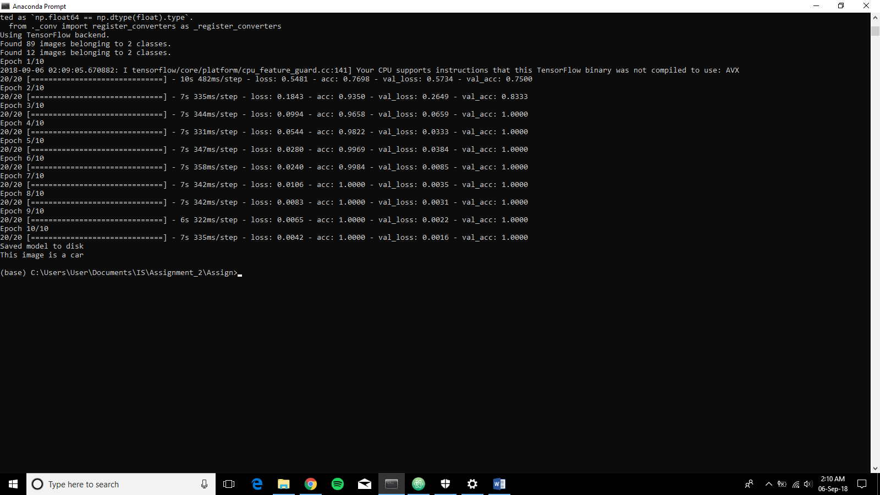

**Task 2.3: Load the CNN model**

* The saved model is already in “Classifier_DN.h5” & “Classifier_DN.json” file.
* To run the saved models and predict the image, run the “Task_2.3.py” code and wait for the code to load the model and make a prediction depending on the image in the validation file.
* Once the model is loaded successfully the prompt "Loaded the h5py file from the disk, ready for prediction!" will pop up on the terminal and the prediction will be made.